HDMI Extender
over one CAT5E/CAT6(TCP/IP)
100 -150m

User manual

Thank you for purchasing this product. For optimum performance and safety, please read these instructions carefully before connecting, operating or adjusting this product. Please keep this manual for future reference.
I. Introduction
The HDMI Extender over ONE CAT 5E/6 is a tool for extending your HDMI signal over long distances to a compatible display. Instead of using expensive HDMI cables, your existing CAT 5E/6 cables/sockets can be utilized to perform advanced functions like transferring Deep Color (12 bits/color) video and digital audio, with a bandwidth up to 225MHz. The HDMI transmitter and receiver, over ONE CAT 5E/6 extender is your substantial HDMI extender tool. The HDMI Extender over ONE CAT 5E/6 also support IR re-transmitting, so you can control the Source which is 100 meters outside using the HDMI Extender.

II. Features
DC 5Vwide power supply.
HDMI 1.3, HDCP 1.1 and DVI1.1 compliant.
Support Deep Color up to 12 bits/color.
Support IR re-transmitting.
Uses one CAT5E/6 cable for data/DDC transmission.
Equalizes and recovers incoming TMDS data before re-transmitting it in optimal quality regardless of the incoming signal quality.
Cable testing showed that with 1080p resolution the HDMI input source can be 20meters away.
When transmitting a signal in 1080p resolution the CAT6 operating distance is 150 meters.

III. Package
HDMI Extender (Transmitter) ------------------------------------ 1PC
HDMI Extender (Receiver )--------------------------------------- 1PC
IR Transmitter ---------------------------------------------------- 1PC
IR Receiver -------------------------------------------------------- 1PC
5V DC Power Supply adapter ----------------------------------- 2PCS
Operation Manual ------------------------------------------------- 1PC

IV. Specifications
Frequency Bandwidth 2.25Gbps (single link)
HDMI Transmitter Input/Output Ports 1x HDMI Female port/1 x CAT6
HDMI Receiver Input/Output Ports 1 x HDMI Female port/1 x CAT6
Power Supply DC 5V
ESD Protection Human Body Model: ± 8kV (air-gap discharge)
± 4kV (contact discharge)
Dimensions (mm) 62(W) X 102 (D) X16 (H)
Operating Temperature 0˚C ~ 40˚C / 32˚F ~ 104˚F
Storage Temperature -20˚C ~ 60˚C / -4˚F ~ 140˚F
Relative Humidity 20~90% RH (non-condensing)
V. Operation controls and Functions
1．HDMI Extender Transmitter
Front Panel Rear Panel
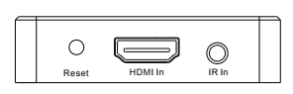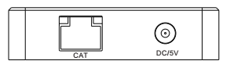

1) Power: Plug the 5V power supply into the unit and connect the adapter to AC wall outlet.
2) RESET KEY: Factory default key.
3) IR In: Remote control signal transmit，connect the IR transmit cable with HDMI
Extender Transmitter; The IR transmit cable face to the IR receiver of the Source．
4) HDMI：HDMI Input port.
5) CAT in: Connect the CAT 5E/6 output of the Transmitter with the CAT 5E/6 input of the HDMI over single CAT6 receiver.

2．HDMI Extender Receiver
Front Panel Rear Panel
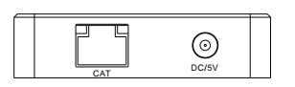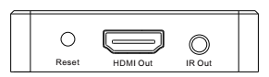
1) Power: Plug the 5V power supply into the unit and connect the adapter to AC wall outlet.
2) RESET KEY: Factory default key
3) IR Out: Remote control signal Receive，connect the IR receive cable with HDMI Extender Receiver．
4) HDMI Out: HDMI output port.
5) CAT Out: Connect the CAT6 in of the receiver with the CAT6 input of the HDMI over single CAT6 transmitter.
VI. Application Example
